In this paper, I will survey the rationale behind attempts at understanding the environmental and genetic factors on the autonomic dysregulation of the condition for hypertension in the spontaneously hypertensive rat (SHR), and human and suggest a complementing model organism the zebrafish, *Danio rerio*. To understand what makes the zebrafish the more appropriate organism I will first cover some basic knowledge about the condition of hypertension and the logic inspiring past approaches at understanding this condition. To appreciate the SHR model organism we will examine biosynthetic, physiological, psychosocial and genetic aspects that have come to demonstrate the complexity and of current studies on cardiovascular disease, hypertension, and autonomic dysregulation.

*The Prevalence of Cardiovascular Disease and Hypertension:*

Cardiovascular disease affects the ability of the heart to deliver blood throughout the body. Failure of proper blood flow through the body can result in a heart attack, stroke or chronic conditions such as Coronary Artery Disease (CAD). (2) Failures of the cardiovascular system are catastrophic for the body and are becoming more common in the United States making 2007 the first year that cardiovascular disease was the leading cause of death, 25% of all deaths in 2007, followed by cancer, 23% of all deaths in 2007. According to the CDC, in 2010 the total cost for health care services, medication, and loss of productivity due to cardiovascular disease totaled $316.4 billion. (13) The cost for treatment and incidence of cardiovascular disease has been projected to increase into the future and this is concurrent with information collected on hypertension, a closely associated risk factor.

The National Health and Nutrition Examination Survey (NHANES) collects epidemiological data on various illnesses including hypertension in the U.S. civilian population. In this survey, hypertension is defined as having a systolic blood pressure (bp) of ≥ 140mmHg, or diastolic blood pressure of ≥ 90mmHG, or taking antihypertension medication. According to this survey 30% of adults aged 20 and older were found to have hypertension. Sodium intake is a major contributor to high bp and it is the influence behind the National Salt Reduction Initiative. Despite national initiatives sodium intake alone is not the only major determinant as to whether an individual will develop hypertension.

*The Kuna and Salt: An Environmental Stressor*

The emphasis on salt is based loosely on the role of the renal cortex. The renal cortex serves to filter the blood and remove toxins and high concentrations of salt were thought to stress the kidney and elicit a detrimental tropic response characteristic of some vascular diseases. Excess salt is a stress on the cortex of the kidney but there are other associated risk factors for hypertension as experienced in the Kuna Indian Tribe that exhibit environmental stressors.

The indigenous Kuna Indians on the islands of the Panamanian Caribbean provide a useful historical control for correlating salt and hypertension. The indigenous Kuna were observed in 1944 to follow a traditional non-industrial lifestyle characterized by a diet where sodium intake is less than 40 mg per day. Due to their island location, the Kuna were said to be under the protection of environmental isolation factors that contributed to a low blood pressure profile. The incidence of hypertension among the indigenous Kuna Indians was virtually non-existent in 1944. (10) Time permitted the environmental protection of the Kuna to succumb to market forces for high sodium diets by means of acculturation and migration.

Over 20 years, acculturation led to a shift in the indigenous Kuna diet for incorporation of salt. The result of acculturation in the native Kuna environment revealed a trend for developing hypertension with increasing age. Time also permitted for the migration of Kuna to suburuban and urban environments. A slight increase in individuals over age 60 was observed for native inhabitants and an absence of increase for the same age group was not observed in other environments. Measurements of both salt intake and excretion, among other parameters, indicated a similar salt composition to the Kuna diet regardless of location and suggest the influence of other factors beyond diet that can serve as major contributors to elevated blood pressure. (5, 9)

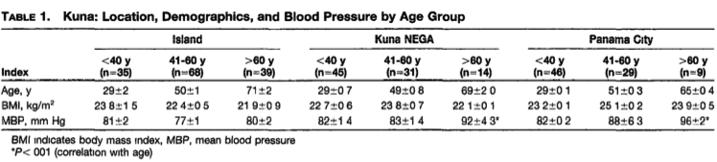

*What is stress: Endocrine System*

The example of the Kuna sheds light on the effects of stress and responses mediated by the central nervous system in response to psychosocial and environmental stimuli. The term stress takes on a new meaning when relating to the psychosocial environment. Stress is the induced mental state, emotions, of the perceived psychosocial environment by the mind. Strain is the resulting pathophysiological response induced by stressful stimuli. It is possible for various stressful stimuli to exert the same strain on the body. Early attempts at understanding the function of stress and strain were undertaken by Hans Selye, often regarded as the father of stress. Selye ambiguously coined the term “stress” for describing the stimulus and pathology for the tropic response of the adrenal medulla to secretion of adrenocorticotropin hormone (ACTH) by the pituitary. (6, 19) ACTH acts on the adrenal medulla of the kidney to release glucocorticoids, steroids, which function to control the body’s utilization of carbohydrates, fats and proteins and help to reduce immune responses to inflammation. The most common of these glucocorticoids is cortisol, often referred to as the stress hormone. An overexpression of ACTH due to a tumor in the pituitary leads to Cushing’s syndrome, which is associated with complications including vascular diseases such as diabetes and hypertension. The ambiguity with Selye’s definition for stress was that it referred to the initiation and propagation of a behaviorally complex pathophysiologic response which is now better understood through mediation of the central nervous system.

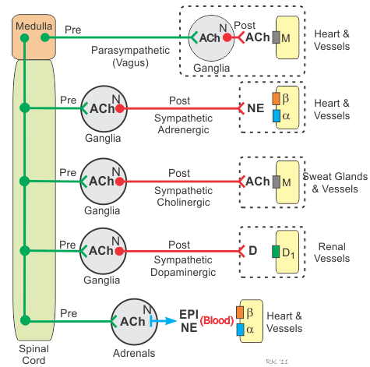*Stress and the Central Nervous System:*

The central, autonomic, nervous system (CNS) has two main branches the sympathetic and the parasympathetic. Both the sympathetic and parasympathetic operate through nicotinic receptors utilizing the neurotransmitter acetylcholine. The adrenal medulla appears as a likely starting point for understanding fluctuations in blood pressure. This diagram

depicts some of the redundant functions of the autonomic nervous system. Excitatory action potentials causing release of acetylcholine (Ach) on the adrenals of the kidney cause the tropic release of the catecholamines epinephrine and norepinephrine which both serve to increase heart rate and cardiac output. The release of these catecholamines into the bloodstream can also work in concert with secretion of glucocorticoids to prepare the body for physiological response to sudden stimuli such as in the fight or flight response. Baroreceptors located in the carotids increase or decrease their rate of firing action potentials by stretching due to changes in blood pressure and can activate the parasympathetic vagus nerve to stimulate the release of acetylcholine onto the muscarinic receptors of the cardiomyocytes of the sinoatrial (SA) node and activation of g-protein coupled receptors. Stimulation of sympathetic adrenergic leads to release of norepinephrine which acts on alpha and ß-adrenergic receptors. Alpha-adrenergic receptors function to function to increase venous return by increasing blood pressure. ß-adrenergic receptors function to adjust ionic conditions of the heart to favor contractions. Alpha and ß-adrenergic receptors are common targets for treatment of cardiovascular disease. (17, 18)

With some basic understanding for the pathways that impact the cardiovascular system we can now begin to examine the usefulness of our model for characterizing the phenotype found in the human population and understanding the orthologous mechanisms in the model organism SHR.

*Major Response Patterns to Startle Stimuli:*

Salt again is not the necessary agent for achieving effect in the cardiovascular system and is not as engaging as secretion of tropic hormones or activation of certain autonomic pathways. The appropriate stress for phenocopying the major mechanisms for controlling blood pressure are initiated by startle such as those that elicit the acute “fight-or-flight” response. Major response patterns exhibited include the vigilance, defense, inhibitory, and defeat response to unsuspected environmental stimuli. (6)

The vigilance response pattern is a transient response that is accompanied with a parasympathetically mediated bradycardia, slowing heart rate, and sympathetically mediated vasoconstriction. The defense reaction is characterized by a sympathetic activation and decreased parasympathetic tone resulting in increased blood pressure and tachycardia, and an increase in heart rate. The defeat reaction is often seen in social animals when status is degraded and corresponds to a drop in sex hormone and functions to increase unit stability by reducing competition for mating and accepting inferior roles of dominance. (6)

The “fight-or-flight” response is characterized by a transient bradycardia as in the vigilance response. This transient bradycardia can then almost instantly switch into a defensive response may prove to be an evolutionary advantage for the animal to escape single encounters chronic activation of this response may prove to be maladaptive. (17, 18) Consider soldiers on the battlefield. The sound of repeated gunfire has an affect to activate the fight or flight response. Individuals with PTSD can encounter the same threatening feeling of fight-or-flight response in the absence of any threats.

*Characterizing the Response to Startle Stimuli in Model Organisms:*

The following selected experiments carried out by Casto characterize the startle response in WKY and SHR by selectively inhibiting function in either the endocrine or central nervous system. In the following experiments, biological parameters include mean arterial pressure and heart rate. The mean arterial pressure for WKY is 105 mmHg and 148 mmHg in SHR. (3, 4, 5) The startle stimulus is a 12.5 psi acoustical air puff that initially elicits an orienting reflex that is mostly represented in the normotensive control WKY. The stimulus was administered for 100ms in successive 30s intervals and the animals were administered a single testing session consisting of 30 stimuli.

*Normotensive Control WKY Response to Startle Stimuli*:

The orienting reflex is the paradigm of response to stimuli and differentiates by application of surgical techniques and pharmacological antagonists resulting in the varied response to the air puff stimuli in later WKY and SHR. The orienting reflex is characterized by a somatomotor reflex, jump, and bradycardia accompanied with vasoconstriction followed by a latent tachycardia. (4) Mean arterial pressure and heart rate increased as a result of the normotensive control WKY exposure to the first several stimuli. Upon further stimulus, however, the somatomotor jumping response is habituated as well as arterial pressure. The bradycardia subsides after 5 stimuli and a latent tachycardia becomes more prevalent. The latency between the initial somatomotor response and following tachycardia indicates that the heart rate is not due to the repeated motor activity requiring additional cardiac output. The habituation of blood pressure does not correspond to physical exertion and the presence of the latent tachycardia is most likely the result of a shift in parasympathetic tone over sympathetic tone.

*Adrenal Medulla Enucleated WKY response to Startle Stimuli:*

Surgical technique was utilized to remove the adrenal medulla by enucleation. Enucleation of the adrenal medulla removes the pathway for sympathetically stimulated trophic release of epinephrine and norepinephrine into the bloodstream. The lacking medulla resulted in a more persistent and exaggerated bradycardia throughout the stimuli followed by a latent tachycardia. There was no measured effect neither on somatomotor response nor arterial pressure.

*4 Week old WKY & SHR response to startle stimuli*

Four-week-old SHR and WKY have comparable resting arterial pressure at this age and resting heart beat. SHR have exaggerated arterial pressure that quickly habituates and a dampened bradycardia response relative to age-matched WKY. (4) The SHR is still characteristic of it exaggerated response to stimuli at this age but does not exhibit the heart rate or blood pressure phenotype as is present in adults. Responses at this age are indicative that the heart rate and blood pressure phenotype of adult SHR is the result of chronic release from the exaggerated sympathetic tone. The sympathetic tone is present before development of established hypertension.

*Effects of Sinoaortic Denervation:*

To determine the effect of the baroreceptor mediated parasympathetic response,

aortic denervation was carried out to characterize heart rate and blood pressure response to startle stimuli. Aortic denervation was performed by cutting the sympathetic trunk and aortic nerve at the carotid artery, the recurrent and superior laryngeal nerves were transected. Sinus denervation was accomplished by stripping fibers and connective tissue from the carotid bifurcation. There was no observed effect on bradycardia to graded doses of phenylephrine, an alpha-adrenergic agonist. (4) Agonist of sympathetic input was from direct input on the heart via innervating nerve fibers and neurotransmitters. The result of this experiment indicates that baroreceptor response must be controlled by the autonomic nervous system.

*Cholinergic Receptor Blockade:*

Atropine methyl nitrate administration to intact WKY rats significantly elevated resting heart rate and arterial pressure compared with control WKY rats (374±7 versus 346±12 beats/min; 128.2±4.5 versus 105.2+23 mmHg). (4) Atropine methyl nitrate abolished the bradycardic response to air puff stimuli in the WKY rat and effectively phenocopied the tachycardic response. However, motor and blood pressure responses to air puff startle were not altered by cholinergjc muscarinic blockade.

*Evidence for Autonomic Dysregulation:*

The experiments carried out by Casto clearly elaborate the various inputs to the heart but were not successful in phenocopying the response of the SHR in terms of an exaggerated and sustained tachycardic and hypertension profile. A way to go about eliciting this would be through the study of genetically linked loci.

The SHR model has served us well for exploring the mechanisms of hypertension but the current technology permits us the ability to identify and to develop medicines that target specific genes instead of symptoms. Due to the multifactorial environmental nature of hypertension alone, it may prove difficult to obtain candidate genes. There are a few traits observed from hypertension that makes it candidate for microarray analysis and genome wide association studies.

*Characteristics of a Hypertension Genetics Study*

The presence or discovery of simple monogenic traits that are linked to hypertension is facilitated now that hypertension may be a pleiotropic disorder with varied environmental influences. The introduction of selection bias accounts for the fact that the traits that might be common for those individuals with hypertension are not common in the general population. A particular intermediate phenotype may be present in all or only in a subgroup of hypertensives. (15) The power of data and computation allow for the discovery of candidate genes. The ideal candidate genes are monogenic in nature and by introducing certain measures of bias into the sampling from the correct phenotype association studies facilitate the ability to uncover particular genes whose function contributes towards the development of hypertension regardless of environmental stressors. (13, 15, 17, 18)

One such GWAS was conducted in the African-American population, which has been observed to be a good candidate for introduction of selection bias due to a disproportionate rate of incidence for hypertension and cardiovascular diseases. The introduction of selection bias is necessary in the case of studying hypertension because there are many contributing factors associated with seemingly normotensive individuals such as in the aforementioned 4-week old SHR and WKY who express virtually the same resting heart rate and blood pressure and differences only emerge after multiple stressful stimuli activate an exaggerated sympathetic tone. Although this pathway may be associated with the autonomic dysregulatory components associated with hypertension, it is not one of the autonomic dysregulatory components that contributes to hypertension. In this experiment carried out by Xavier University special note was taken in describing the conditions for the groupings of patterns of expression certain individuals would be involved. The groups involved in this study included individuals with an isolated systolic blood pressure elevation, an isolated diastolic blood pressure elevation, and those with both. (1)

When comparing the results for the most highly associated gene for SBP in this study to another GWAS of individuals of European ancestry correlated one gene PMS1 which is associated with colorectal cancer. The rates of incidence for colorectal cancer among African Americans in the United States is the highest of any other race group with roughly

Conclusion that the genetic contribution to hypertension, even in populations where we expect a higher incidence of hypertension there is no outstanding genetic correlation.

Figure 3, page 13, outlines the pathways involved in systemic regulation of SBP and DBP according to Adeyemo. This figure gives a basic sense for the complexity of the nature of genetic contribution to hypertension as identified in humans. The need for a simpler model is evident by studies conducted in humans and the SHR is the result of efforts to exaggerate the phenotype for hypertension in the hope of uncovering a linkage pattern.

*Selecting for the Spontaneously Hypertensive Rat Phenotype*

When designing the SHR model organism of hypertension, the creators sought to combine the emerging genetic predisposition and an exaggerated characterization of the hypertension condition through selective matings. In 1963, Kozo Okamoto revealed basic linkage when he mated a Wistar-Kyoto (WKY) male rat with spontaneously high systolic bp, 150-175 mmHG, and a female WKY rat with slightly elevated bp, 130-140 mmHg, to obtain F1 rats. (16) The F1 rats possessing bp greater than 150 mmHG were grouped together and mated with their hypertensive siblings and this process was continued until the generation of F6 rats. In the F3 to F6 generation, 100% of the progeny exhibited the spontaneously hypertensive blood pressure profile and crosses to normotensive WKY resulted in a 3:1 ratio of hypertensive to non-hypertensive offspring.

*Validity for Cosegregation of Heart Rate and Hypertension:*

A testcross between SHR males and WKY females, demonstrated motor and cardiovascular responsiveness not different from WKY parents. Brother-sister mating of F-1 animals produced an F-2 generation with widely distributed blood pressures. Segregation of F2 progeny by systolic blood pressure yielded a 1:3 distribution. (3) Neither group showed abnormal somatomotor or blood pressure responses to startle stimuli. However, the F2 group with elevated arterial pressure exhibited tachycardia to startle that was similar to SHR parental generation. The heart rate response to acute stress may serve as a more informative marker for hypertension than either the behavioral or blood pressure response as utilized by Aoki in originally developing the SHR model in support for emerging evidence for hypertension to be a condition that results from autonomic dysregulation.

*Identifying Candidate Genes from oligonucleotide specific microarray analysis of renal medullary cells:*

To rule out the possibility that expression patterns in the renal medulla are majorly involved in determining the blood pressure profile tissue specific oligonucleotide microarray analysis was performed to create an expression profile. The presentation for candidate genes in two different strains for the blood pressure profile, SHR and blood pressure high (BPH) rat were examined and evidenced to utilize different expression patterns for involvement in several different systems including adrenal catecholamines and sympathetic function; steroid hormone synthesis, catabolism and its contribution to enhanced glucocorticoid sensitivity in SHR, oxidative stress, and intermediary metabolism. Roughly 10% of the differentially expressed orthologs shared a common direction of expression between the SHR and BPH renal medullary tissues. (7) The evidence collected from this experiment is that the genetic contribution to hypertension is pleiotropic and much more complex than previously imagined. (Friese)

*DNA Fingerprinting suggests divergence within SHR strain:*

Genetic characterization of the SHR is most likely futile from the aforementioned correlation to two hypertensive models and the SHR model itself. DNA fingerprinting analysis of the leading sources in the world for supply the SHR for experimental study, the National Institutes of Health and the Shimane Institute of Health, does not yield any identifiable restriction fragment polymorphisms that are specific for the SHR. (14) A possible explanation for this divergence requires looking back to the Casto experiment in 4-week old SHR. There is evidence that the condition of hypertension brings about many complications. A plausible mechanism for acquiring these complications are changes in gene expression or regulation. The lack of similarity within generations is further compounded when one considers that the modern day SHR are the result of more than 50 generations of interstrain breeding. Simply the SHR model has been stressed beyond its ability for consistency.

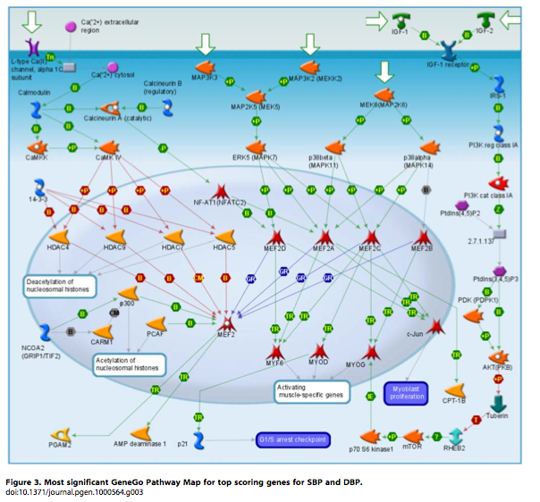*Conclusion:*

In conclusion, the initial symptoms that might indicate significant linkage to the condition for hypertension are over simplifications. Although salt may be publicly viewed as a preventative measure for hypertension it is not sufficient to counterack the damage to the autonomic nervous system that allows the condition to persist. Genetic heritability for the disease may be observable in the SHR model but it is severely weakened by its greater degree for variability. The major remarkable disadvantage for the SHR system is that the process seems to be conserved in the zebrafish. The zebrafish modeling for acute stress response corresponds to a transient bradycardia and following bradycardia. (12) Screening for mutants has led to the discovery of particular phenotypes for the central nervous system. For example the mutant *bajan* has a point mutation in a gene encoding for the enzyme choline acetyltransferase (CHaT) that remarkable allows the mutant to function with low neuromuscular transmission. (20) Despite evolutionary divergence studies in the zebrafish may prove to be complementary to those already advanced and quickly approaching their limitation in the SHR model.